console.count or console.countReset
count how many times a particular string gets logged in the console

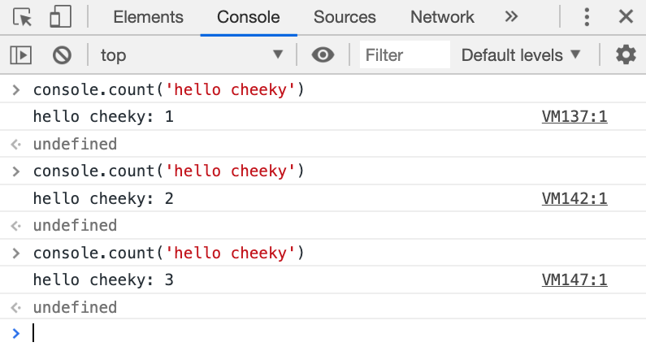

console.table
to describe an object or array at a human readable table
